Tshishonga Thuso

Student N.O: 13093802

Electromagnetic Theory EMM780 Assignment#2 Report

School of Electrical, Electronic and Computer Engineering, University of Pretoria

**Abstract**

# Introduction

This document provides a report on the EMM780 assignment#2. Modal analysis technique was to used to analyse and characterise an H-Step discontinuity of a rectangular waveguide. Modal analysis technique was used to implement a GNU Octave program that analyses the H-Step waveguide discontinuity and produce a plot of the magnitude of the dominant mode. Figure 1 demonstrates the x – z axis cross – section of the rectangular waveguide with a discontinuity at z = 0. Table 1 details the dimensions of the waveguide.

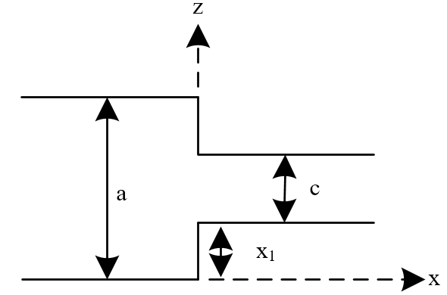

Figure 1: x – z cross-section of the waveguide

Table 1: waveguide dimensions

|  |  |  |
| --- | --- | --- |
| Parameter | Description | Value |
| a | Width of guide a | 22.86 mm |
| b | Waveguide height | 10.16 |
| c | Width of guide c | 18 mm initially |
| L | Total length of the waveguide | 100 mm |
| x1 | Length of discontinuity | ($\frac{a-c}{2}$) = 2.54 mm initially |

This report is structured as follows: section 2 provides the mathematical modelling of the discontinuity using modal analysis, section 3 provides details of the implemented GNU Octave software program, section 4 provides the Octave software program and CST studio analysis results of the discontinuity.

# Mathematical Modelling

Figure 2 demonstrates the cross-section plot of the discontinuity in the x-y axis. The discontinuity has a change only in the x-direction (width), only the Ey is affected by the discontinuity. Modal analysis example in section 4.4 in [1] was modified to develop equations of this assignment. It was assumed that the dimension of both sections of the waveguide allow only for the dominant mode TE10 to propagate. The electric ($E_{y}^{i}$) and magnetic ($H_{x}^{i}$) fields that are incident on the discontinuity are represented by equation 1 and 2 where $Z_{1}^{a}$ is the mode 1 (m =1, n = 0) intrinsic impedance of guide a. Equations 3 and 4 represent the electric and magnetic fields that reflected at the discontinuity where $A_{m}$ is the magnitude of the reflected mode. Equations 5 and 6 represent the transmitted electric and magnetic fields where $B_{m}$ and $Z_{m}^{c}$ represent the magnitude of the transmitted modes and the intrinsic impedance of mode m respectively.

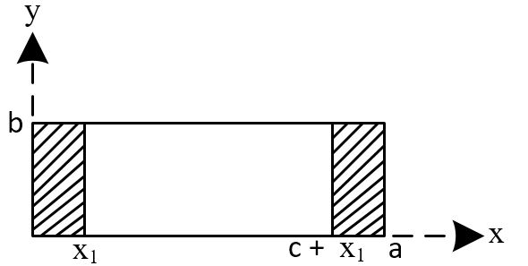

Figure 2: x – y cross-section of the waveguide at z = 0

$E_{y}^{i}= \text{sin}{\frac{\text{πx}}{\text{a}}e^{jβ_{1}^{a}Z}}$ (1)

$H_{x}^{i}=\frac{-1}{Z_{1}^{a}}\text{sin}{\frac{\text{πx}}{\text{a}}e^{jβ_{1}^{a}Z}}$ (2)

$E_{y}^{r}= \sum_{\text{m=1}}^{\text{∞}}{A_{m}\text{sin}{\frac{\text{m}\text{πx}}{\text{a}}e^{jβ_{m}^{a}Z}}}$ (3)

$H_{x}^{r}=\frac{-1}{Z_{m}^{a}} \sum_{\text{m=1}}^{\text{∞}}{A_{m}\text{sin}{\frac{\text{m}\text{πx}}{\text{a}}e^{jβ_{m}^{a}Z}}}$ (4)

$E_{y}^{t}= \sum_{\text{m=1}}^{\text{∞}}{B_{m}\text{sin}{\frac{\text{m}\text{πx}}{\text{a}}e^{jβ_{m}^{c}Z}}}$ (5)

$H_{x}^{t}=\frac{-1}{Z_{m}^{c}} \sum_{\text{m=1}}^{\text{∞}}{B_{m}\text{sin}{\frac{\text{m}\text{πx}}{\text{a}}e^{jβ_{m}^{c}Z}}}$ (6)

Because the discontinuity is only in the x-direction, the all tangential electric fields will sum to zero at the discontinuity (at 0 < x < x1 and c+x1 < x < a). Both electric and magnetic fields are continuous at x1 < x < c + x1. These boundary conditions lead to the following continuity equations:

$E_{y}= \text{sin}{\frac{\text{πx}}{\text{a}}+ } \sum_{\text{m=1}}^{\text{∞}}{A_{m}\text{sin}{\frac{\text{mπx}}{\text{a}} }}=\left\{\begin{aligned}\begin{aligned}\sum_{\text{m=1}}^{\text{∞}}{B_{m}\text{sin}{\frac{\text{mπx}}{\text{a}}} for x_{1}< x < c + x_{1} } \\ \end{aligned} \\ 0 for 0 < x < x_{1} and c+ x_{1}< x < a \end{aligned}\right.$ (7)

$H_{x}= \frac{-1}{Z_{1}^{a}}\text{sin}{\frac{\text{πx}}{\text{a}}+ }\sum_{\text{m=1}}^{\text{∞}}{A_{m}\text{sin}{\frac{\text{mπx}}{\text{a}}} }= \frac{-1}{Z_{m}^{c}} \sum_{\text{m=1}}^{\text{∞}}{B_{m}\text{sin}{\frac{\text{mπx}}{\text{a}}}} for x1< x < c + x1$ (8)

Multiplying equation 7 by $\sin{\frac{pπx}{a}}$ and integrating from $x=0 to x=a$ for $p=m$ results in equations 9, 10, and 11. Equation 8 multiplied by $\sin{\frac{qπx}{a}}$ and integrated from $x=x1 to x=$ $c + x1$ for $q=m$ results in equations 12, 13, and 14. The coefficients of the dominant modes $A_{m}$ and $B_{m}$ by solving the matrix equation 15. tht

# octave Software Program

The GNU Octave software program was written using multiple .m-file function. The description of these .m-file functions is summarised in table 2. In order to run the program, the user must the main.m file using the GNU Octave IDE. Running the main.m file runs the main function and all other functions that used in analysing the discontinuity. The program will magnitude plots of reflected dominant mode (A1).

# Analysis Results

# CoNCLUSION

References

1. D.M. Pozar, Microwave Engineering, 4th Edition, John Wiley & Sons